**Online Application Title: e-RTO System**

**Team:** Aniket Jain

Sidak Bhatia

-------------------------------------------------------------------------------------

# SRS Document:

# Purpose of Project:

This document contains the complete software requirements for e-RTO System and describe the design decisions, architectural design needed to implement the system. It provides the visibility in design and provide Information needed for software support. The proposed system is aimed to automate the major processes in the Regional Transport Office.

E-RTO Management System for different License.

# Scope of project:

“RTO Management System” is aimed to automate the major processes in Regional Transport Offices. The scope of Online RTO Management system includes a complete suite of portal to provide citizens with 24/7 access to services like Online Registration for Learner's license & permanent license, Examination and maintaining results, Management of time slots for driving tests.

The main motive of the system is to make the daily activities efficient and providing fast response by storing and retrieving information & informing it to the users via SMS or E-Mail.

# Definition:

RMS-RTO Management System.

SRS-Software Requirement Specification.

GUI-Graphical User Interface.

Stack Holder-The person who will participate in the system (Admin, CITIZENS).

# Overview:

Now a day’s many people are purchasing two wheelers, four wheelers etc. So the RTO employees having lot of work burden of making registration. License issue, transfer etc. which required lot of paper work. As a result people cannot get the things done in right time, which waste the time, energy. Similarly the vehicle owner sometimes forgets to carry the license at the time of enquiry. So to overcome these drawbacks we are developing an enhanced e-RTO Management System. Such like that we provide one type of environment which gives a user friendly means user can access and understand well. Administrator has the power to verify the data entered by the user, processing of data and provide appropriate solutions.

# Overall Description:

e- RTOManagement system is an advanced system which is designed keeping in view to make the existing registration system easier and faster. It includes the entire registration procedure starting from the initial phase of entering till the results. It is more reliable, accurate time, saving and free from any misuse. The tedious jobs such as verifying all the records of the applicant, confirming all the personal details are furnished, submission of documents, driving license, registration details, etc. are done in the most convenient way to the administrator. Also security is being provided in the most proficient way.

The aim is to build a user-friendly webpage where the citizens can apply for learner’s license, driving license. The webpage also provides provision for citizens to submit their complaints.

Mainly, the website is used for issuing of license. An individual can apply for learning license and driving license online. Accordingly, slots and dates are generated for the respective test. The application received will be verified and approved by the RTO officials. The applicant can monitor the status of their application.

To implement this system we have used spring boot, java. It provides support to all major servers like Apache and databases like MySQL. Next, we have used React, Bootstrap4, CSS, JavaScript, HTML5 for front-end implementation. They provide a front-end development framework to create fully responsive web pages and define proper styles and presentation of the document. Lastly, MySQL is used as the back-end database since it is one of the most popular open source databases, and it provides fast data access, easy installation and simplicity.

User has 2 roles ADMIN and CITIZEN.

### 1) ADMIN:

The super user, admin class represents complete authority over the system. The following activities are performed by Admin can:-

1. Login as Admin.
2. Admin has two list Permanent License List and Learning License

List.

1. Admin perform two operation on List, Admin can either edit or delete.
2. Admin can change status of Learning License:
   1. Booked
   2. Completed
   3. Written Slot Issued
   4. Written Test Passed
   5. Written Test Failed
   6. Applied For Permanent License
3. Similarly, Admin can change status as Citizen for Permanent License:
   1. Booked
   2. Completed
   3. Driving-Pass
   4. Driving-Slot-Issued
   5. Driving-Fail

1. Delete the Permanent or Learning License.

### 2) CITIZEN:

i. Citizen has to register providing details as name, email, and password. ii. Citizen has to Login as Citizen.

1. Apply for Learning and Permanent License providing details in brief.
2. Provide documents. (ex. Aadhar Card , Photograph, Signature)

Citizen can attend mock test. vi. Can check the status

# Functional Requirement:

### ◆Scenario 1: Mainline Sequence

1. Admin:

Login, Enter Email and Password.

1. System:
   1. Display the Admin dashboard
   2. Admin can see citizen Learning License or Permanent License List as well as Edit and Delete.

### ◆Scenario 2: Mainline Sequence

1. Citizen:

Registered, enter Name Email and Password.

Login, Enter Email and Password

1. System:
   1. Home
   2. Apply for License:-
      * For Learning License :-
      1. Fill Learning License Application Form
      2. Upload Documents
      3. If registered successfully, Success Page will be shown
      * For Permanent License :-

i. If registered successfully, Success Page will be shown

* 1. Attempt Mock Test.

Check your status

# Non-Functional Requirement:

• Following Non-Functional Requirements will be there in the insurance to the internet:-

* Secure access to consumer’s confidential data.
* 24X7 availability.
* Better component design to get better performance at peak time.
* Flexible service based architecture will be highly desirable for future extension.
* Security.
* Reusability.
* Maintainability.
* Reliability.
* Portability.
* Extensibility.

# Database Tables

**User Table:**

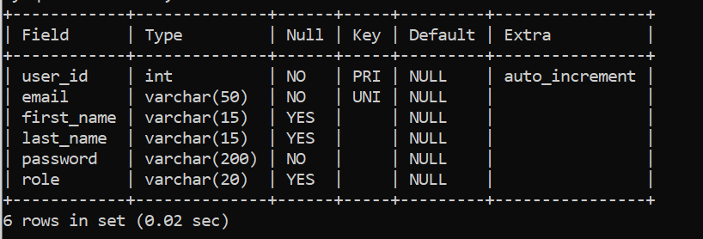

**Learning License Table:**

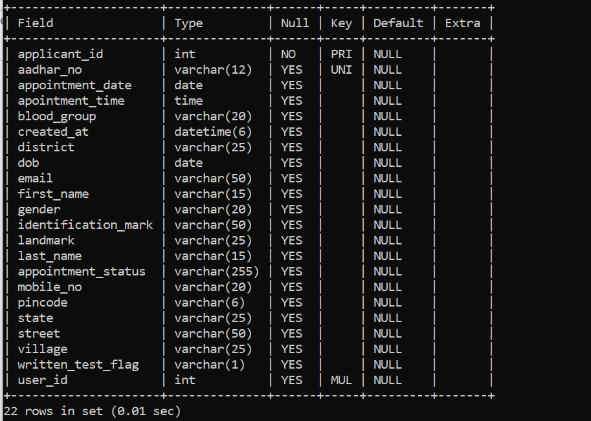

**Permanent License Table:**

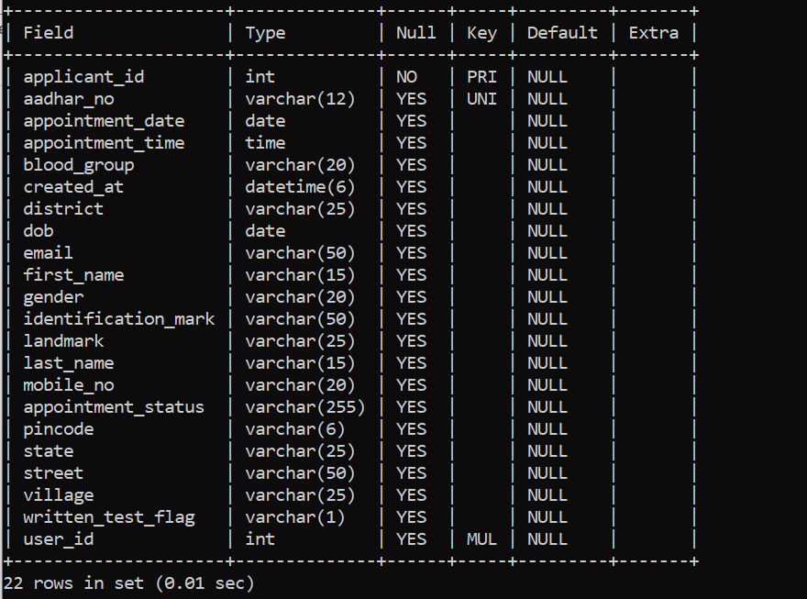

**Image Table:**

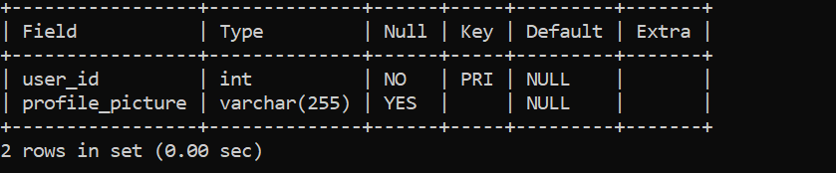

**App_ id Table:**

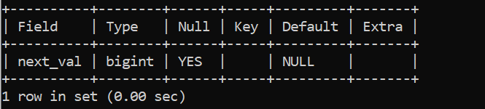

# Conclusion

* The application is design in such a way that any further enhancements can be done with ease. The system has the capability for easy integration with other systems. New modules can be added to the existing system with less effort.
* In future a new function or procedure can be easily added in the system through these classes. Or even a new class can be added.
* The system generated only a limited number of reports. If more detailed reports are required the system can be directed Even though the system has well communication facility, it’s not enough.
* The mail service can be enhanced with features bcc, cc etc. The system has full security but the account information for the customer credit information.
* Improved communication, ease of access to RTO resources such as Registration forms etc.. , will help foster a stronger user relationship.
* e - RTO management will empower you to spend more time and effort developing your users’ lifelong learning license.
* In this e-RTO management complete global Module. (Any Where Any Time)
* In this system the main entity is Admin who has all the right.
* Here the main tasks of admin are update/delete registration, license.